Name: ___________________ Date: ___________
NBT.4 Rounding Decimal Numbers Resource Page
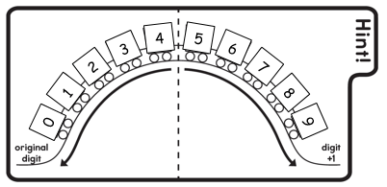
Strategies:
1.

2. Rhyming Mnemonic (reminder)
5 or more – up the score!
4 or less – let it rest!
3. Number lines
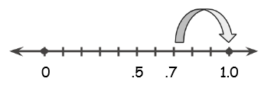
.7 rounded to the nearest whole number is 1.0

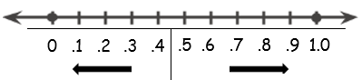

Name: ___________________ Date: ___________
NBT.4 Rounding Decimal Numbers Resource Page
Strategies:
1.

2. Rhyming Mnemonic (reminder)
5 or more – up the score!
4 or less – let it rest!
3. Number lines
.7 rounded to the nearest whole number is 1.0

